Problem Statement 8: Designing a Non-Relational Database Model equivqlent to a RelationalModelfor Person Schema

* I created Azure Cosmos DB using the SQL API
* I used fake data to design a JSON document such that the person’s information is all embedded in a single JSON document
* I created fake data where I have people with single and multiple addresses to show the JSON schema.
* I had to go online to Microsoft Documentation to look for ideas to solve my problem.
* The problem I encountered is that while copying codes from my visual studio to my Cosmos data studio, I missed out the last curly bracket and the codes did not save. I had to compare the codes line-by-line to realise the mistake which I corrected.

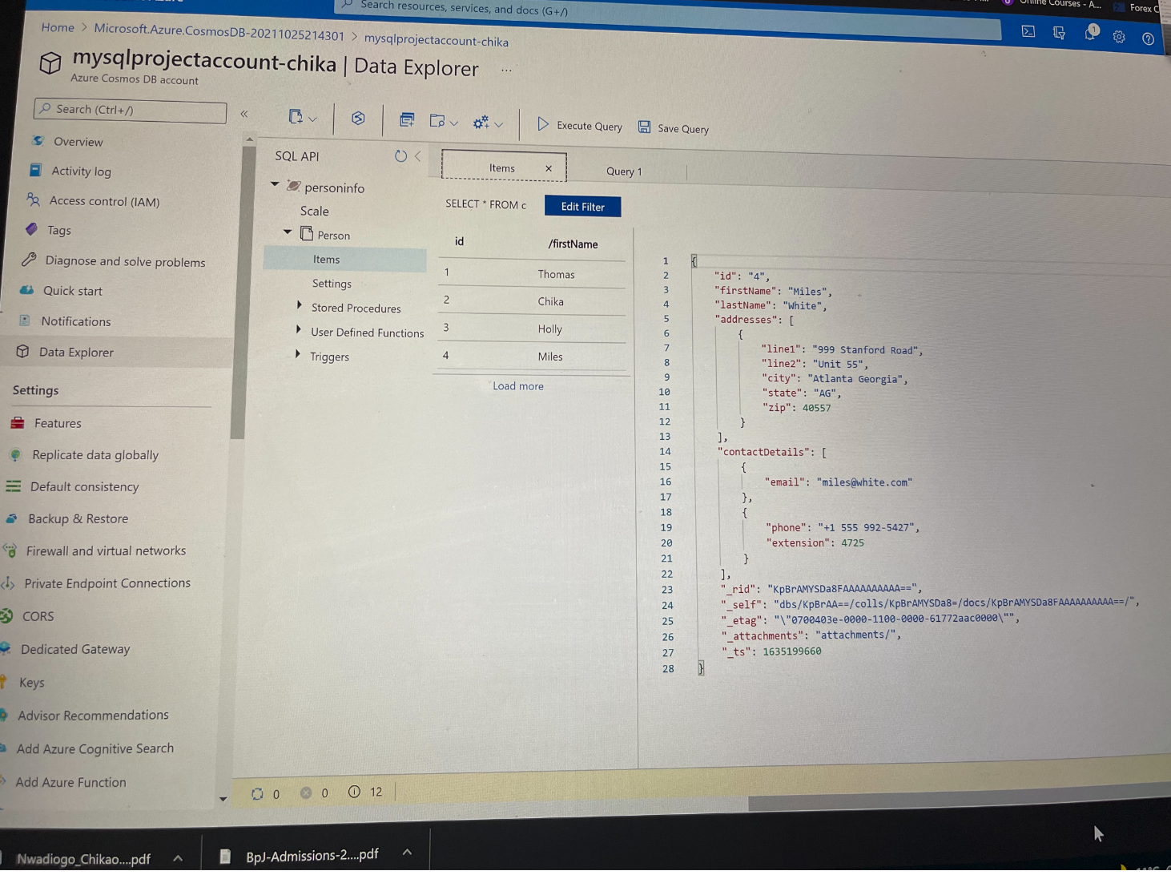

Figure 1: JSON document of a client with single address

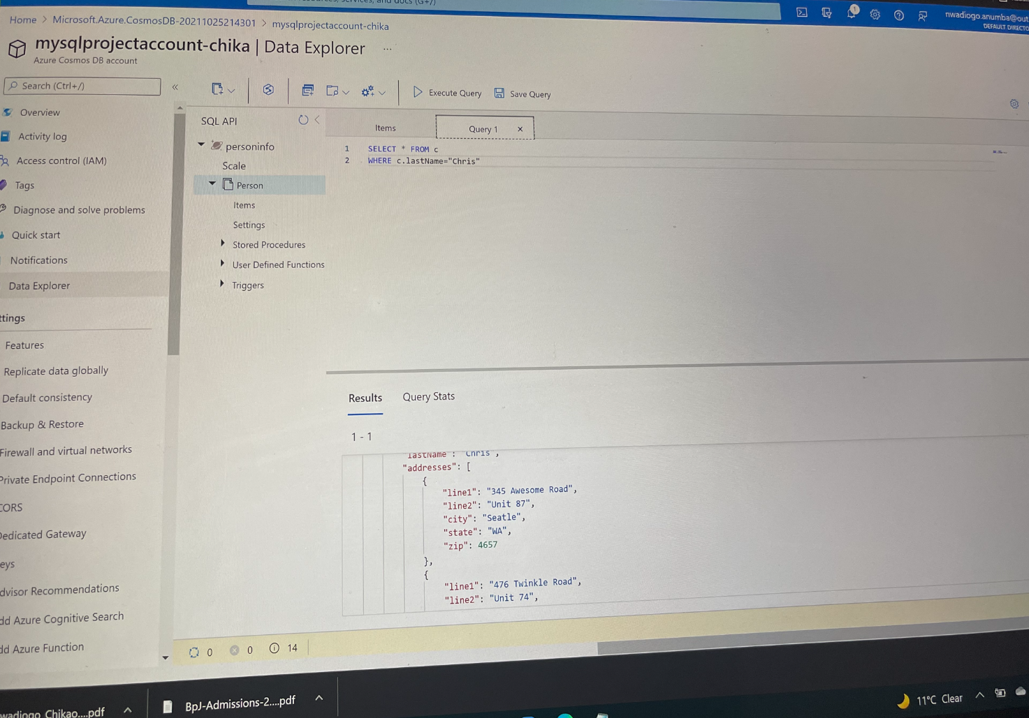

Figure 2: JSON document of a client with multiple addresses